# **End Course Summative Assignment**

Problem Statement: Write the Solutions to the Top 50 Interview Questions and Explain any 5 Questions in a Video

Imagine you are a dedicated student aspiring to excel in job interviews. Your task is to write the solutions for any 50 interview questions out of 80 total questions presented to you. Additionally, create an engaging video where you thoroughly explain the answers to any five of these questions.

Your solutions should be concise, well-structured, and effective in showcasing your problem-solving skills. In the video, use a dynamic approach to clarify the chosen questions, ensuring your explanations are easily comprehensible for a broad audience.

**Note:**

1. **Make a copy of this document and write your answers.**
2. **Include the Video Link here in your document before submitting.**

**Contribution - Individual**

**Questions:**

**1.** **What is a vector in mathematics?**

A vector is a quantity that has both magnitude (length) and direction.

1. **Magnitude:** This is the length or size of the vector, usually denoted by |v| for a vector v
2. **Direction:** This indicates the direction in which the vector is pointing.

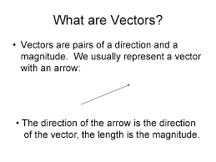

Vectors can be represented in multiple ways: Graphically(arrow in a coordinate system), Algebraically (In two dimensions, a vector v can be represented as u = ux i + uy j, where i and j are unit vectors along the x-axis and y-axis, respectively. In three dimensions, a vector v is represented as u = ux i + uy j + uz k. We can perform the following actions with the vector Addition, Subtraction,Scalar Multiplication,Dot Product, Cross Product (3D)

**2. How is a vector different from a scalar?**

**Vector:** A quantity that has both magnitude and direction.

**Scalar:** A quantity that has only magnitude, without any direction.

**Representation:**

**Vector:** Represented by arrows in diagrams and by components in algebra u = ux i + uy j

**Scalar:** Represented by numerical values, e.g., 5, -3.2

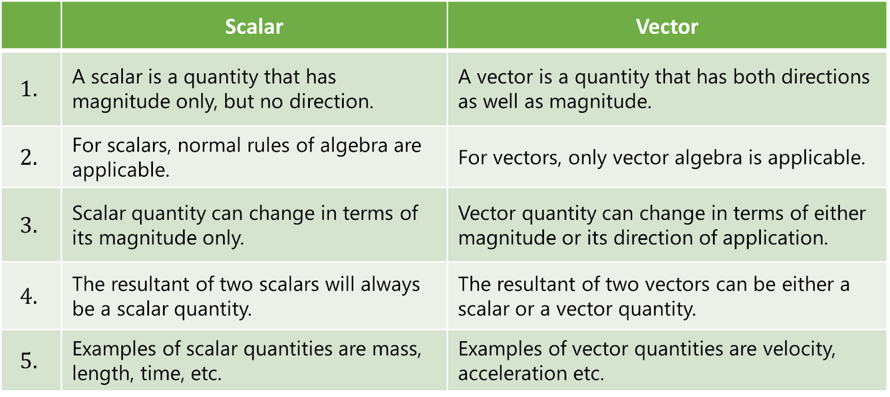

**Examples:**

* **Vector:**
  + Displacement (d)
  + Velocity (v)
  + Force (F)
* **Scalar:**
  + Temperature (25°C)
  + Mass (10 kg)
  + Time (5 seconds)

#### **Operations:**

* **Vector:** 
  + Addition: u+v
  + Subtraction: u−v
  + Scalar Multiplication: cv
  + Dot Product: u⋅v
  + Cross Product (in 3D): u×v
* **Scalar:**
  + Addition: a+b
  + Subtraction: a−b
  + Multiplication: a×b
  + Division: a/b

#### **Summary:**

* Vectors have both magnitude and direction, making them suitable for describing quantities like force and velocity.
* Scalars have only magnitude and are used to describe quantities like temperature and mass.

**3. What are the different operations that can be performed on vectors?**

* **Vector Addition:** Combining two vectors to form a resultant vector. = U + V
* **Vector Subtraction:** Finding the vector difference between two vectors. = U - V
* **Scalar Multiplication:** Multiplying a vector by a scalar (real number). If c is a scalar and v is vector then cv.
* **Dot Product (Scalar Product):** Producing a scalar from two vectors. = U . V
* **Unit Vector:** A vector with a magnitude of 1.
* **Addition of Multiple Vectors:** Adding more than two vectors together. = U1 + U2… + Un

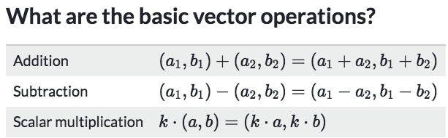

### **Summary**

These operations allow for a wide range of mathematical manipulations and applications of vectors in various fields such as physics, engineering, computer graphics, and more.

**4. How can vectors be multiplied by a scalar?**

Multiplying a vector by a scalar involves scaling the vector by the scalar's value, changing the vector's magnitude while keeping its direction unchanged (or reversing it if the scalar is negative).

#### **Mathematical Representation**

If v is a vector and c is a scalar, the scalar multiplication of c represented as cv

Example:

If v contains (3,4) and c = 2 means answer would be (6,8)

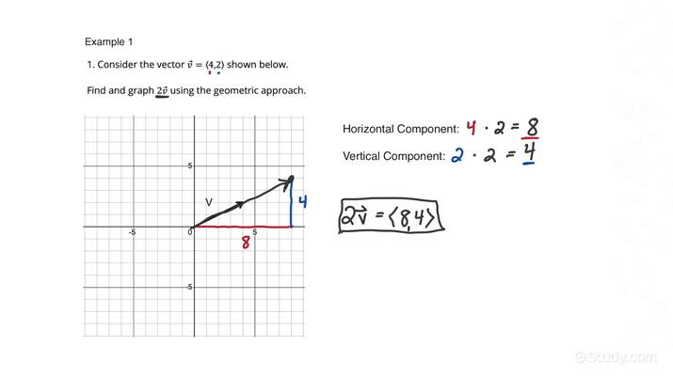

#### **Effects of Scalar Multiplication**

* **Scaling Up:** When |c| > 1, the vector is stretched, making it longer.
* **Scaling Down:** When 0 < |c| < 1, the vector is shrunk, making it shorter.
* **Reversal:** When c < 0, the vector's direction is reversed.

### **Summary**

Multiplying a vector by a scalar adjusts the vector's length by the scalar's value while maintaining (or reversing) its direction. This operation is essential in various applications, such as physics for scaling forces, computer graphics for transforming objects, and more.

**5. What is the magnitude of a vector?**

The magnitude of a vector (also known as the length or norm) is a measure of its length. It is a non-negative scalar quantity that represents the distance from the vector's initial point to its terminal point in Euclidean space.

#### **Notation**

The magnitude of a vector v is denoted as |v|

Formula:

|v| = sqrt( U1^2 + U2^2 +...+ Un^2 )

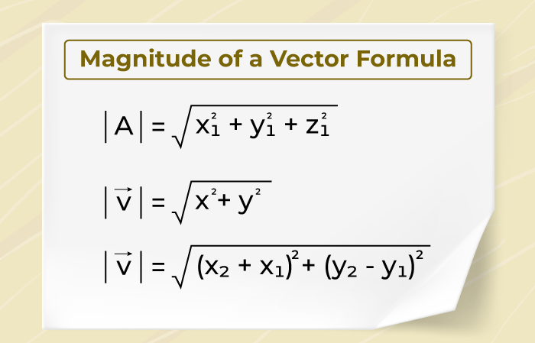

#### **Summary**

The magnitude of a vector provides a measure of its length, which is fundamental in various fields, including physics, engineering, and computer graphics. It helps in understanding the vector's scale and is crucial for normalizing vectors and computing distances between points.

**6. What is the difference between a square matrix and a rectangular matrix?**

#### **Square Matrix**

A square matrix is a matrix with the same number of rows and columns. In other words, if a matrix has ‘n’ rows, it also has ‘n’ columns making it as a n x n matrix.

**Characteristics:**

**Diagonal Elements:** Square matrices have a main diagonal, which runs from the top left to the bottom right of the matrix.

#### **Rectangular Matrix:**

A rectangular matrix is a matrix where the number of rows and columns are not equal. This means that if a matrix has ‘m’ rows, it has ‘n’ columns, where m ≠ n.

Characteristics:

**No Diagonal:** Unlike square matrices, rectangular matrices do not have a main diagonal that spans from the top left to the bottom right.

#### **Summary of Differences:**

1. **Dimensions:**
   * **Square Matrix:** n x n
   * **Rectangular Matrix:** m x n (where m ≠ n)
2. **Diagonal Elements:**
   * **Square Matrix:** Has a main diagonal.
   * **Rectangular Matrix:** Does not have a main diagonal spanning from top left to bottom right.

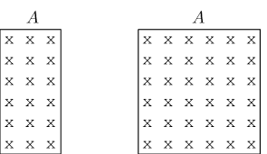

In summary, the key difference lies in the equality or inequality of the number of rows and columns. Square matrices have equal rows and columns, leading to special mathematical properties, while rectangular matrices have differing numbers of rows and columns and do not share these properties.

**7. What is the basis of linear algebra?**

A basis in linear algebra is a set of vectors in a vector space that are linearly independent and span the entire space. This means that every vector in the vector space can be uniquely expressed as a linear combination of the basis vectors. It is the science of numbers that empowers diverse Data Science algorithms and applications. To fully comprehend machine learning, linear algebra fundamentals are the essential prerequisite

**Linearly Independent:** A set of vectors is linearly independent if no vector in the set can be written as a linear combination of the others. This ensures that each basis vector adds a new dimension to the vector space.

**Spanning Set:** A set of vectors spans a vector space if any vector can be expressed as a linear combination of the vectors in the set.

**Applications of Linear Algebra in Data Science**

* Coordinate Transformations
* Linear Regression
* Dimensionality Reduction
* Natural Language Processing
* Computer Vision
* Network Graphs

#### **Summary:**

* **Basis:** A set of linearly independent vectors that span the vector space.
* **Linearly Independent:** No vector in the set can be expressed as a linear combination of the others.
* **Spanning Set:** Any vector in the space can be expressed as a linear combination of the set.

A basis provides a convenient way to describe and work with all vectors in the vector space by expressing them in terms of the basis vectors.

**8. What is a linear transformation in linear algebra?**

A **linear transformation** is a function between two vector spaces that preserves the operations of vector addition and scalar multiplication. In simpler terms, a linear transformation maps vectors to vectors in such a way that the structure of the vector space is maintained. In simple terms, a linear transformation is a function that meets the additive and homogenous properties. Examples of linear transformations include y = x, y = 2x, and y= 0.5x

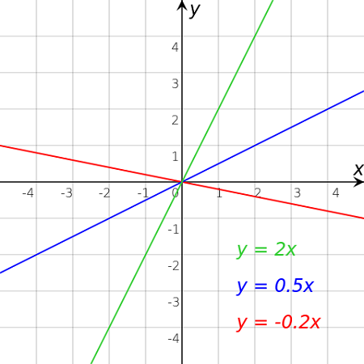

**9. What is an eigenvector in linear algebra?**

An eigenvector in linear algebra is a special type of vector associated with a square matrix. When this matrix is applied to the eigenvector, the result is a new vector that points in the same direction as the original eigenvector, but possibly with a different magnitude. The factor by which the eigenvector is scaled is called the eigenvalue.   
**Formally**, for a square matrix A, a vector v is an eigenvector if it satisfies:

**Av=λv**

Where:

A is the square matrix,

v is the eigenvector,

λ is the eigenvalue associated with v.

**Summary**:

Eigenvectors and eigenvalues are fundamental concepts in linear algebra that describe how a matrix can act on a vector by simply scaling it rather than changing its direction. These concepts are widely used in various applications, including solving systems of linear equations, performing dimensionality reduction in data analysis (like PCA), and analyzing dynamic systems. Understanding eigenvectors and eigenvalues provides deep insights into the properties and behavior of linear transformations.

**10. What is the gradient in machine learning?**

In machine learning, the gradient is a vector containing the partial derivatives of a function (usually the loss function) concerning each of its parameters. It indicates the direction and rate of the steepest increase in the function's value.

The gradient is used primarily in optimization algorithms like gradient descent, where the goal is to minimize the loss function by iteratively updating the model's parameters in the opposite direction of the gradient. By doing so, the algorithm "descends" towards the minimum value of the loss function, ideally leading to a model that makes accurate predictions.

**∇f(x, y) = (df/dx, df/dy)**

**Explanation:**

∇f(x,y) : This denotes the gradient of the function f(x,y).

∂f/ ∂x ​: This is the partial derivative of f concerning x, indicating how f changes as x changes while keeping y constant.

∂f/ ∂y: This is the partial derivative of f concerning y, indicating how f changes as y changes while keeping x constant.

**11. What is backpropagation in machine learning?**

**Backpropagation** (short for "backward propagation of errors") is an algorithm used in training artificial neural networks. It is essential for optimizing the network by adjusting its weights based on the error (or loss) of the network's predictions.

In backpropagation, the network's output is compared with the target output to calculate the error. This error is then propagated backward, layer by layer, to update the weights. This process is repeated iteratively, allowing the network to learn the mapping from inputs to outputs.

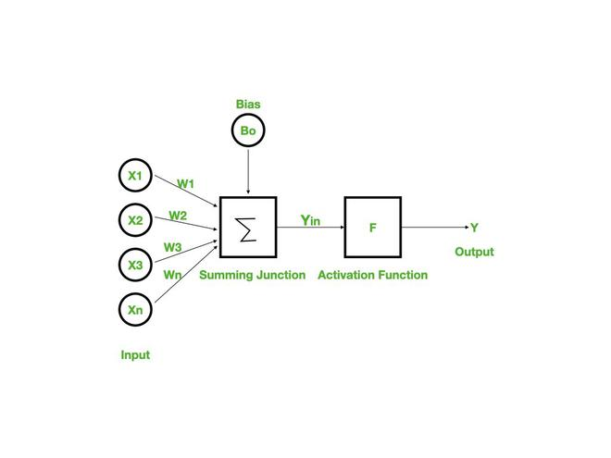

### **How Backpropagation Works:**

1. **Forward Pass**:
   * Inputs are passed through the network, layer by layer, to produce an output (prediction).
   * The output is compared to the actual target using a loss function, which calculates the error.
2. **Backward Pass**:
   * The error is propagated backward through the network.
   * The algorithm calculates the gradient of the loss function with respect to each weight in the network by applying the chain rule of calculus.
   * These gradients indicate how much the loss would change if the weights were adjusted.
3. **Weight Update**:
   * The weights are updated by moving them in the direction that reduces the loss, typically using an optimization method like gradient descent.

**Summary:**

Backpropagation is an algorithm used to train artificial neural networks. It calculates the gradient of the loss function with respect to each weight by propagating the error backward through the network.

**12. What is the concept of a derivative in calculus?**

A derivative in calculus represents the rate at which a function changes as its input changes. It's the slope of the tangent line to the function at a given point. For a function f(x), the derivative f ′ (x) gives the rate of change of f with respect to x.

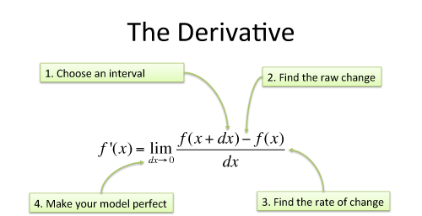

**13. How are partial derivatives used in machine learning?**

**Partial derivatives** play a crucial role in machine learning, particularly in the optimization of models, such as training neural networks and other algorithms that involve minimizing or maximizing a function (typically the loss function). Probability theory is a branch of mathematics that deals with the analysis of random events. It helps to quantify the likelihood of different outcomes.

**∂f/∂x, ∂f/∂y**

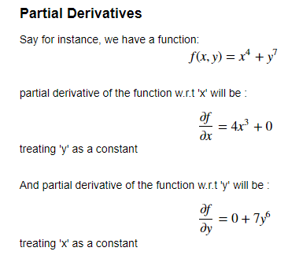

**14. What is probability theory?**

**Probability theory** is a branch of mathematics that studies uncertainty and the likelihood of different outcomes. It provides a formal framework for quantifying and reasoning about randomness, uncertainty, and the chances of various events occurring.

**P(A) = Number of favorable outcomes / Total outcomes**

### **Key Concepts in Probability Theory:**

1. **Probability**:
   * Probability measures how likely an event is to occur, expressed as a number between 0 and 1.
   * A probability of 0 indicates that an event is impossible, while a probability of 1 indicates that an event is certain to occur.
   * For an event A, the probability is denoted as P(A).
2. **Random Variables**:
   * A random variable is a variable that can take on different values based on the outcome of a random event.
   * Random variables can be **discrete** (taking on a finite or countable number of values) or **continuous** (taking on an infinite number of possible values).
3. **Probability Distributions**:
   * A probability distribution describes how the probabilities are distributed over the possible values of a random variable.
   * For discrete random variables, the probability distribution is often given by a **probability mass function (PMF)**.
   * For continuous random variables, the distribution is described by a **probability density function (PDF)**.
4. **Expected Value**:
   * The expected value (or mean) of a random variable is a measure of the "central" value expected in the long run, calculated as a weighted average of all possible values.
5. **Law of Large Numbers**:
   * This theorem states that as the number of trials or observations increases, the average of the results will converge to the expected value.
6. **Central Limit Theorem**:
   * This theorem states that the distribution of the sum (or average) of a large number of independent, identically distributed random variables will approximate a normal distribution, regardless of the original distribution of the variables.

### **Applications of Probability Theory:**

* **Statistical Inference**: Probability theory is the foundation of statistics, enabling us to make inferences about populations based on sample data.
* **Risk Assessment**: Used in finance, insurance, and various fields to quantify and manage risk.
* **Machine Learning**: Probabilistic models and techniques like Bayesian inference rely heavily on probability theory.

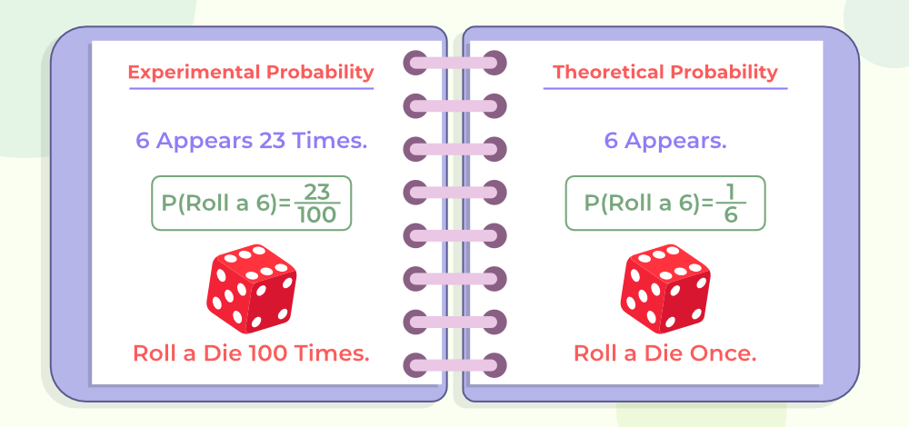

### **Summary:**

Probability theory provides a mathematical framework for analyzing situations involving uncertainty and randomness. It is fundamental to fields such as statistics, machine learning, finance, and many scientific disciplines. By understanding and applying the principles of probability, we can quantify uncertainty, make predictions, and inform decision-making in the face of unknowns.

**15. What are the primary components of probability theory?**

The primary components include events, sample spaces, probabilities, random variables, and probability distributions.

* **Sample Space (Ω):**

The sample space is the set of all possible outcomes of a random experiment. For example, in a coin toss, the sample space is Ω = { Heads , Tails }

* **Events:**

An event is any subset of the sample space. It represents one or more outcomes that we are interested in. For example, the event of getting an even number when rolling a die can be represented as E = { 2, 4, 6 }.

* **Probability Measure (P):**

The probability measure assigns a probability to each event in the sample space. It is a function F → [0, 1], where F is the set of events. The probability of the entire sample space is P(Ω) = 1. The probability of an event E is P(E), which must satisfy 0 ≤ P(E) ≤ 1.

* **Random Variables:**

A random variable is a function that assigns a real number to each outcome in the sample space. There are two types of random variables: Discrete Random Variables: Take on a finite or countable set of values (e.g., the number of heads in three coin tosses). Continuous Random Variables: Take on an infinite number of values within a range (e.g., the exact time it takes to complete a task).

### **Summary:**

The primary components of probability theory include the sample space, events, probability measure, random variables, probability distributions, expectation, variance, conditional probability, independence, and Bayes' Theorem. These components form the foundation for analyzing and understanding random processes and are crucial for applications in statistics, machine learning, and various scientific disciplines.

**16. What is a conditional probability, and how is it calculated?**

Conditional probability is the probability of an event occurring given that another event has already occurred. It quantifies how the likelihood of an event changes when you know that a related event has taken place. If A and B are two events in probability space, the conditional probability of A given B is denoted by P(A∣B) and is defined as:

**P(A|B) = P(A ∩ B) / P(B)**

Provided that P(B) > 0.

P(A∩B) is the probability that both events A and B occur.

P(B) is the probability that event B occurs.

### **Summary:**

Conditional probability is a measure of the probability of an event occurring given that another related event has already occurred. It is calculated using the formula P(A | B) = P(B) P(A ∩ B) ​ . This concept is essential for understanding how the likelihood of events changes based on additional information or conditions, and it is widely used in fields like statistics, machine learning, and risk assessment.

**17. What is the Bayes theorem, and how is it used?**

Bayes's theorem describes the probability of an event based on prior knowledge of conditions related to the event. It is used in various fields, including machine learning and statistics.

The formula for Bayes' Theorem is:

**P (A|B) = [P(B|A) * P(A)] / P(B)**

Where:

P(A | B) is the posterior probability: the probability of event A given that event B has occurred.

P(B | A) is the likelihood: the probability of event B given that event A is true.

P(A) is the prior probability: the initial probability of event A before any evidence is considered.

P(B) is the marginal probability: the total probability of event B occurring.

Using Bayes' Theorem helps in combining prior knowledge with new evidence to make more informed and accurate assessments.

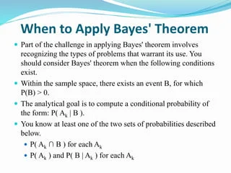

**18. What is a random variable, and how is it different from a regular variable?**

A **random variable** is a concept from probability theory and statistics used to quantify the outcomes of a random phenomenon. It is fundamentally different from a regular (deterministic) variable in several ways: X: {0, 1, 2, ...}

### **Random Variable**

* **Definition**: A random variable is a function that maps outcomes of a random process to numerical values. It is used to describe the results of a random experiment in terms of probability.
* **Types**:
  + **Discrete Random Variable**: Takes on a finite or countably infinite number of values. Example: The number of heads in 10 coin flips.
  + **Continuous Random Variable**: Takes on an infinite number of values within a given range. Example: The height of a person.
* **Probability Distribution**: A random variable is associated with a probability distribution that describes the likelihood of different outcomes. For discrete random variables, this is often represented by a probability mass function (PMF), and for continuous random variables, it is represented by a probability density function (PDF).
* **Expectations**: The expected value (or mean) of a random variable is the long-term average value it takes on over numerous trials. Variance and standard deviation measure the dispersion of its possible values.

### **Regular Variable**

* **Definition**: A regular variable, in the context of non-random processes, is a variable whose value is determined deterministically, meaning it doesn't involve randomness or uncertainty.
* **Examples**: The number of apples in a basket, the price of a product, or the length of a piece of wood are examples of regular variables where the value is fixed and known precisely.
* **No Probability Distribution**: Regular variables do not have a probability distribution associated with them, as their values are not subject to randomness or variability.

### **Key Differences**

1. **Randomness**:
   * **Random Variable**: Represents outcomes of a random process with inherent uncertainty.
   * **Regular Variable**: Represents fixed values without uncertainty.
2. **Probability Distribution**:
   * **Random Variable**: Associated with a probability distribution that provides the likelihood of different outcomes.
   * **Regular Variable**: No associated probability distribution.
3. **Usage**:
   * **Random Variable**: Used in probability theory and statistics to model and analyze random processes.
   * **Regular Variable**: Used in deterministic contexts where outcomes are not influenced by random factors.

In summary, random variables are central to probabilistic modeling and statistical inference, whereas regular variables are used in deterministic contexts where outcomes are predictable and not influenced by chance.

**19. What is the law of large numbers, and how does it relate to probability theory?**

The **Law of Large Numbers (LLN)** is a fundamental concept in probability theory and statistics that describes the behavior of sample averages as the sample size increases. It provides a foundation for the reliability of statistical estimates based on large samples.

**Sample mean -> Expected value as n -> ∞**

The sample mean converges in probability to the expected value as the sample size approaches infinity.The Law of Large Numbers states that as the number of trials or observations increases, the sample mean (average) of the observed values tends to get closer to the expected value (theoretical mean) of the random variable. There are two main forms of the Law of Large Numbers:

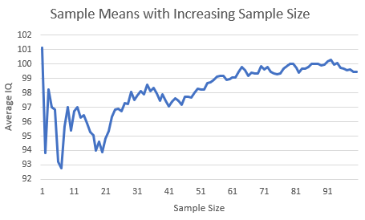

In summary, the Law of Large Numbers is a cornerstone of probability theory that ensures that the average of a large number of random variables will converge to the expected value. This concept underpins much of statistical analysis and data science, providing the assurance that large sample estimates are reliable approximations of population parameters.

**20. What is the central limit theorem, and how is it used?**

The central limit theorem states that the distribution of the sum (or average) of a large number of independent, identically distributed random variables approaches a normal distribution, regardless of the original distribution. It is crucial for making inferences about population parameters from sample statistics.

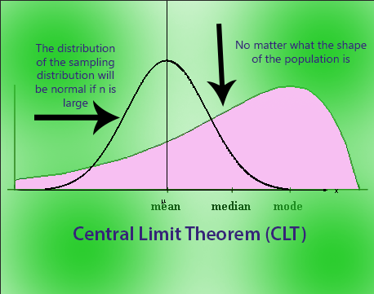

**n -> ∞, distribution -> Normal**

### **Example**

* **Example with Dice Rolls**: Suppose you roll a fair six-sided die multiple times and calculate the average of the rolls. According to the CLT, as the number of rolls increases, the distribution of the average roll will approximate a normal distribution centered around the expected value (3.5) with a standard deviation related to the number of rolls.

In summary, the Central Limit Theorem is a powerful statistical tool that allows for the approximation of the sampling distribution of the mean with a normal distribution. This approximation simplifies many statistical procedures and is fundamental to modern statistical analysis.

**21. What is the difference between discrete and continuous probability distributions?**

Discrete probability distributions describe the probabilities of outcomes for discrete random variables (e.g., rolling a die), while continuous probability distributions apply to continuous random variables (e.g., the height of a person).

#### **Discrete Probability Distributions Characteristics**

* **Countable Outcomes**: The set of possible values is finite or countably infinite (e.g., 1, 2, 3, ...).
* **Probability Mass Function (PMF)**: The probability distribution is described by a probability mass function, which gives the probability of each possible outcome.
* **Sum of Probabilities**: The sum of probabilities for all possible outcomes equals 1.
* **Examples**: Common examples include the binomial distribution, Poisson distribution, and geometric distribution.

**Continuous Probability Distributions Characteristics**

#### **Characteristics**

* **Uncountable Outcomes**: The set of possible values is uncountably infinite and can be any value within an interval (e.g., all real numbers between 0 and 1).
* **Probability Density Function (PDF)**: The distribution is described by a probability density function, which defines the relative likelihood of outcomes within a continuous range. The probability of any exact value is zero, but probabilities are calculated over intervals.
* **Examples**: Common examples include the normal distribution, exponential distribution, and uniform distribution.

### **Examples**

* **Discrete**:
  + Rolling a die (each outcome has a non-zero probability).
  + Number of emails received in a day.
* **Continuous**:
  + Measuring a person’s height (can take any value within a range).
  + Time between arrivals of buses (continuous distribution of time values).

In summary, the distinction between discrete and continuous probability distributions lies in the nature of the outcomes they describe and the methods used to calculate probabilities.

**22. What are some common measures of central tendency, and how are they calculated?**

Measures of central tendency are statistical metrics used to describe the center point or typical value of a dataset. The most common measures are the mean, median, and mode. Here’s how each is calculated and what they represent:

### **1. Mean**

**Definition**: The mean, often referred to as the average, is the sum of all values in a dataset divided by the number of values.

**Mean = Σx / N**

### **2. Median**

**Definition**: The median is the middle value of a dataset when it is ordered from smallest to largest. If the dataset has an even number of values, the median is the average of the two middle values.

**Median = Middle value**

### **3. Mode**

**Definition**: The mode is the value or values that occur most frequently in a dataset. A dataset may have one mode, more than one mode, or no mode at all if no value repeats.

**Mode = Most frequent value**

### **Summary of Differences**

* **Mean**: Provides the arithmetic average and is sensitive to extreme values (outliers). Suitable for normally distributed data.
* **Median**: Represents the middle value and is less sensitive to outliers. Useful for skewed distributions.
* **Mode**: Represents the most frequent value(s) and can be used with nominal data. There can be multiple modes or no mode.

Each measure of central tendency provides different insights into the data and is useful depending on the nature of the data and the specific characteristics being analyzed.

**23. What is the purpose of using percentiles and quartiles in data summarization?**

Percentiles and quartiles are used to describe the distribution of data. Percentiles divide data into 100 equal parts, each representing 1% of the data. They help in understanding the relative position of a value within the dataset, while quartiles divide data into four equal parts, helping to understand the spread and identify outliers. **Q1, Q2 (Median), Q3**

**First Quartile (Q1)**: The 25th percentile, below which 25% of the data falls.

**Second Quartile (Q2)**: The 50th percentile, also known as the median, below which 50% of the data falls.

**Third Quartile (Q3)**: The 75th percentile, below which 75% of the data falls.

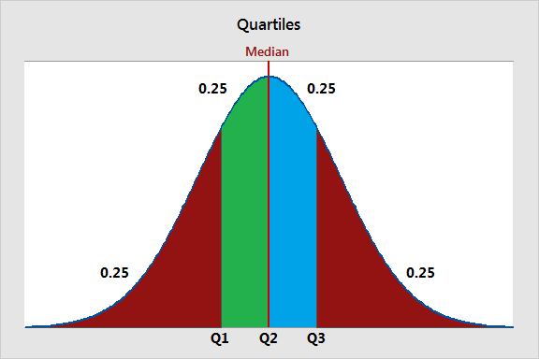

### **Summary**

* **Percentiles** provide a detailed breakdown of data points by ranking their relative position.
* **Quartiles** summarize the data into four segments, making it easier to understand the distribution and detect outliers.

Together, these measures offer a comprehensive view of the data's distribution and help in identifying trends, comparisons, and deviations within the dataset.

**24. How do you detect and treat outliers in a dataset?**

Detecting and treating outliers is crucial for ensuring the quality and accuracy of data analysis. Outliers can skew statistical results and affect the performance of machine learning models. Here’s how you can detect and handle them:

**Visual Methods**

* **Box Plot**: A box plot (or whisker plot) visualizes the distribution of data and highlights outliers. Outliers typically appear as points outside the "whiskers" of the box plot.
* **Scatter Plot**: For bivariate data, scatter plots can help identify outliers as points that deviate significantly from the overall trend.

**Statistical Methods**

* **Z-Score**: The Z-score measures how many standard deviations a data point is from the mean. A Z-score above a certain threshold (e.g., 3 or -3) is often considered an outlier.

**Machine Learning Methods**

* **Isolation Forest**: An algorithm that isolates observations by randomly selecting a feature and splitting values.
* **DBSCAN (Density-Based Spatial Clustering of Applications with Noise)**: A clustering algorithm that identifies outliers as points that do not belong to any cluster.

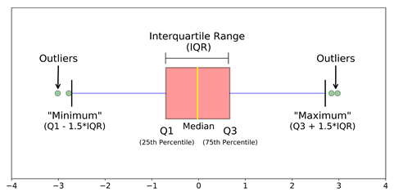

### **Treatment of Outliers**

* Data Transformation
  + Log Transformation: Applying a log transformation can reduce the impact of extreme values.
  + Square Root or Box-Cox Transformation: These transformations can stabilize variance and make the data more normally distributed.
* Data Imputation
  + Replace with Mean/Median: Outliers can be replaced with the mean or median of the non-outlier values.
  + Use Predictive Models: Impute missing or extreme values using models based on other features.
* Removing Outliers
  + Manual Removal: If outliers are due to errors or are not relevant to the analysis, they can be removed from the dataset.
  + Automated Methods: Use algorithms like Isolation Forest or Z-score thresholds to remove outliers systematically.
* Capping or Winsorizing
  + Capping: Limit the values of outliers to a certain percentile (e.g., replacing values above the 95th percentile with the value at the 95th percentile).
* Segmentation
  + Treat Separately: Sometimes, outliers may represent a different segment of the data that requires separate analysis.

**|----|-----|----|**

**Q1 Q2 Q3**

**Outliers outside**

### **Summary**

* Detecting Outliers: Use visual methods (box plots, scatter plots), statistical methods (Z-score, IQR), or machine learning methods (Isolation Forest, DBSCAN).
* Treating Outliers: Apply transformations, imputation, removal, capping, or segmentation based on the context and impact on the analysis.

**25. How do you use the central limit theorem to approximate a discrete probability distribution?**

The Central Limit Theorem (CLT) is a fundamental concept in probability theory that helps approximate the distribution of a sample mean from a discrete probability distribution. Here’s how you can use the CLT to approximate a discrete probability distribution:

**Discrete distribution -> Normal distribution (n -> ∞)**

### **Summary**

The CLT allows you to approximate the distribution of the sample mean from a discrete probability distribution using a normal distribution, provided the sample size is large enough. This approximation is useful for making probabilistic statements and inferences about the sample mean.

**26. How do you test the goodness of fit of a discrete probability distribution?**

Testing the goodness of fit for a discrete probability distribution involves determining how well a theoretical probability distribution matches the observed data. Goodness of fit can be tested using methods like the Chi-square test, which compares observed frequencies with expected frequencies under a specific distribution.

**Chi-Square Goodness of Fit Test**

The Chi-Square Goodness of Fit Test is widely used to assess whether the observed frequencies of categories match the expected frequencies based on a theoretical distribution.

**Chi-square: Σ[(O - E)^2 / E]**

where O is the observed frequency and E​ is the expected frequency for category i.

### **Summary**

To test the goodness of fit of a discrete probability distribution, you can use methods like the Chi-Square Goodness of Fit Test, Likelihood Ratio Test. Each method involves comparing the observed data to the expected theoretical distribution and assessing whether there is a significant discrepancy.

**27. What is a joint probability distribution?**

A joint probability distribution describes the probability of two or more random variables occurring simultaneously. It provides a comprehensive view of the likelihood of various combinations of outcomes for these random variables.

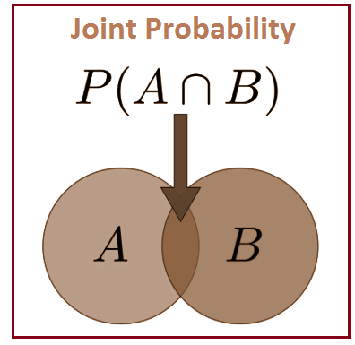

### **Applications**

1. **Understanding Relationships:**
   * Joint probability distributions help in understanding the relationship between two or more random variables. They are useful in fields like statistics, machine learning, and data science to model and analyze complex dependencies.
2. **Modeling Dependencies:**
   * They are crucial in modeling dependencies in multivariate data, where the outcome of one variable may affect or be affected by the outcome of another.
3. **Predictive Modeling:**
   * In machine learning and statistical modeling, joint distributions are used to make predictions about the behavior of multiple variables based on their interrelationships.

In summary, a joint probability distribution provides a complete picture of the likelihood of various combinations of outcomes for multiple random variables, capturing their interdependencies and enabling deeper insights into their relationships.

**28. How do you calculate the joint probability distribution?**

The joint probability distribution is calculated by finding the probability of each combination of outcomes for two random variables and can be represented in a table or matrix.

#### **Discrete Random Variable Steps to Calculate:**

1. Identify All Possible Outcomes
2. Calculate the Joint Probability
3. Construct the Joint Probability Table

**Continuous Random Variables Steps to Calculate:**

1. Identify the Joint PDF
2. Normalize the Joint PDF

### **Summary**

* Discrete Variables: List all possible pairs and their probabilities, often constructing a joint probability table.
* Continuous Variables: Use the joint PDF and integrate over the desired range to find probabilities.

Both methods provide a comprehensive understanding of the relationship between the random variables in question.

**29. What is the difference between a joint probability distribution and a marginal probability distribution?**

A joint probability distribution provides the probabilities of combined outcomes for multiple variables, while a marginal probability distribution provides the probabilities of a single variable's outcomes, obtained by summing the joint probabilities over the other variables.

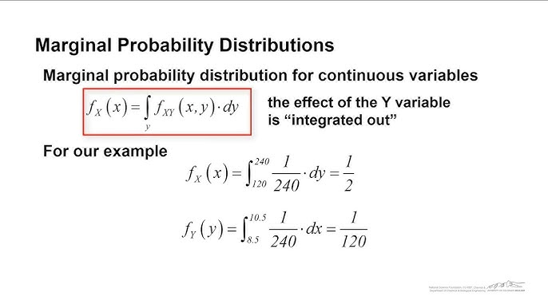

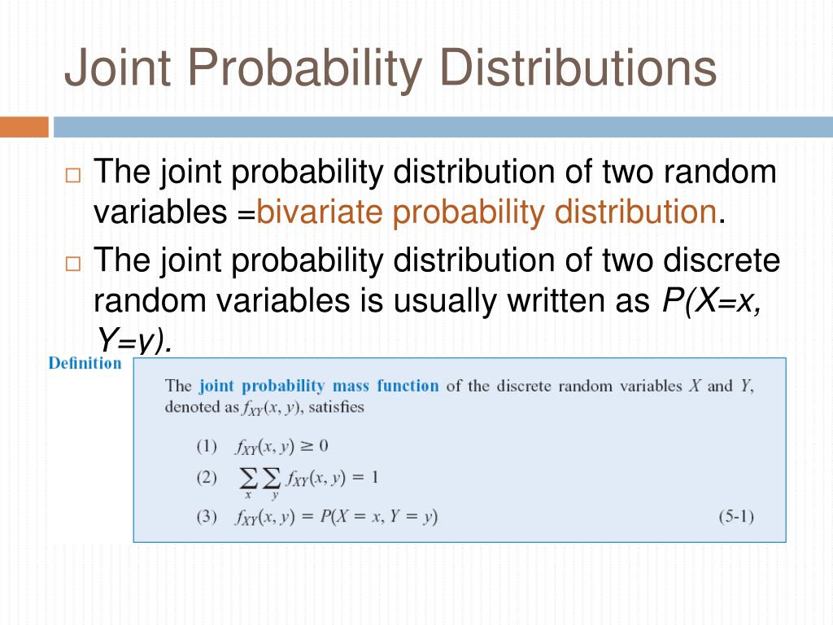

### **Summary:**

* **Joint Probability Distribution:** Describes the probability of two or more random variables simultaneously.
* **Marginal Probability Distribution:** Describes the probability of a single random variable, obtained by summing or integrating out the other variables in the joint distribution.

**30. What is the covariance of a joint probability distribution?**

Covariance is a measure of how two random variables in a joint probability distribution change together. It indicates the degree to which two variables are linearly related.

**Cov(X, Y) = E[(X - μX)(Y - μY)]**

Where,

* E[X] and E[Y] are the expected values (means) of the random variables X and Y.
* E[ (X−E[X])(Y−E[Y]) ] represents the expected value of the product of the deviations of X and Y from their respective means.

### **Interpretation:**

* **Positive Covariance:** Indicates that as one variable increases, the other variable tends to increase as well.
* **Negative Covariance:** Indicates that as one variable increases, the other variable tends to decrease.
* **Zero Covariance:** Indicates that there is no linear relationship between the variables, although they may still have a non-linear relationship.

Covariance is a fundamental concept in statistics, used in areas like finance (e.g., to measure the relationship between asset returns), data analysis, and machine learning.

**31. How do you determine if two random variables are independent based on their joint probability distribution?**

Two random variables are independent if the joint probability distribution equals the product of their marginal distributions: P(X,Y)=P(X) P(Y).

**P(X, Y) = P(X)P(Y) -> Independent**

If the joint distribution equals the product of the marginal distributions for all values of x and y, then X and Y are independent. If the condition fails for even a single pair of values, then X and Y are not independent.

**32. What is the relationship between the correlation coefficient and the covariance of a joint probability distribution?**

The correlation coefficient and the covariance of a joint probability distribution are closely related, but they capture different aspects of the relationship between two random variables.

**ρ(X, Y) = Cov(X, Y) / (σXσY)**

### **Relationship Between Covariance and Correlation Coefficient:**

The correlation coefficient is essentially a normalized form of covariance. It scales the covariance to a range between −1 and 1, making it easier to interpret and compare the strength and direction of the linear relationship between two variables, regardless of the units of measurement.

In summary:

* **Covariance** gives the magnitude and direction of the relationship between two variables, but it is sensitive to the scale of the variables.
* **Correlation coefficient** standardizes this relationship, making it scale-invariant, and providing a clearer measure of the strength and direction of the linear relationship.

**33. What is sampling in statistics, and why is it important?**

**Sampling** in statistics is the process of selecting a subset of individuals, items, or observations from a larger population to estimate characteristics or make inferences about the entire population. This subset is known as a "sample."

**Population -> Sample**

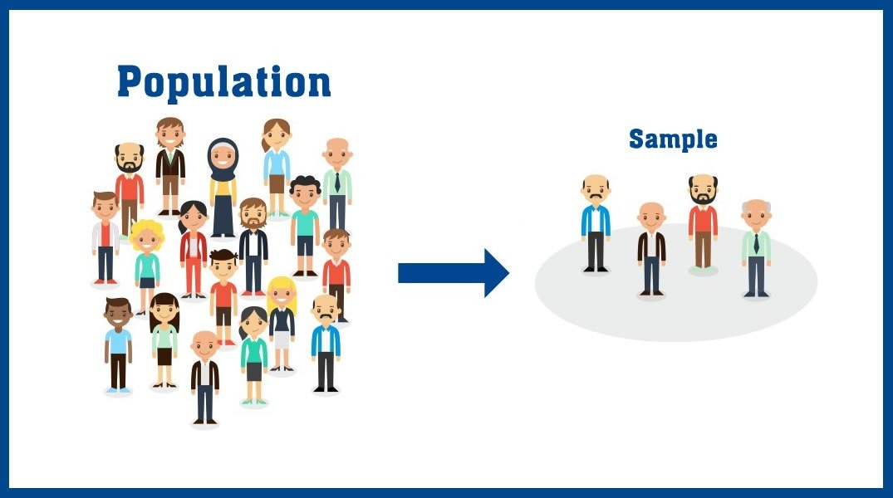

### **Types of Sampling:**

1. **Probability Sampling:**
   * Every member of the population has a known, non-zero chance of being selected. Examples include simple random sampling, stratified sampling, cluster sampling, and systematic sampling.
2. **Non-Probability Sampling:**
   * The selection of the sample is based on subjective judgment rather than random selection. Examples include convenience sampling, judgmental sampling, quota sampling, and snowball sampling.

### **Importance of Sampling:**

* **Cost Reduction:**
  + Sampling reduces the overall cost of data collection because fewer resources are required to gather and analyze data from a sample than from an entire population.
* **Faster Data Collection:**
  + By focusing on a sample rather than the whole population, researchers can collect and analyze data more quickly, allowing for faster decision-making.
* **Accuracy and Precision:**
  + A well-designed sample can provide accurate and reliable estimates of population parameters. Proper sampling techniques help minimize bias and ensure that the sample is representative of the population.
* **Practicality in Large Populations:**
  + In large populations, it is often impossible to conduct a complete census. Sampling provides a practical alternative that still allows for meaningful insights.

In summary, sampling is a crucial tool in statistics that allows researchers to gather and analyze data efficiently, make inferences about populations, and make data-driven decisions while managing constraints on time, cost, and resources.

**34. What are the different sampling methods commonly used in statistical inference?**

In statistical inference, various sampling methods are used to select a sample from a population. These methods can be broadly categorized into two types: **probability sampling** and **non-probability sampling**.

### **1. Probability Sampling:**

In probability sampling, every member of the population has a known, non-zero chance of being selected in the sample. This type of sampling allows for the generalization of results from the sample to the population.

#### **a. Simple Random Sampling:**

* **Description:** Every member of the population has an equal chance of being selected. This can be done using random number generators or drawing names from a hat.
* **Advantages:** Reduces selection bias, easy to understand and implement.
* **Disadvantages:** May not be practical for large populations.

#### **b. Cluster Sampling:**

* **Description:** The population is divided into clusters, usually based on geographical areas or other natural groupings. A random sample of clusters is selected, and then all members or a random sample of members within each selected cluster are surveyed.
* **Advantages:** Cost-effective for large, geographically dispersed populations.
* **Disadvantages:** Higher sampling error compared to simple random or stratified sampling if clusters are not homogeneous.

#### **c. Multistage Sampling:**

* **Description:** Combines several sampling methods. For example, a researcher might use cluster sampling to choose clusters, and then simple random sampling to choose individuals within those clusters.
* **Advantages:** Flexible and practical, especially for large populations.
* **Disadvantages:** Complex and may introduce more sampling error if not properly designed.

### **2. Non-Probability Sampling:**

In non-probability sampling, not all members of the population have a chance of being included in the sample. These methods are often used when probability sampling is impractical.

#### **a. Convenience Sampling:**

* **Description:** Samples are taken from a group that is conveniently accessible to the researcher.
* **Advantages:** Easy, quick, and inexpensive.
* **Disadvantages:** High risk of bias, not representative of the population, limited generalizability.

#### **b. Judgmental/Purposive Sampling:**

* **Description:** The researcher selects the sample based on their judgment about which individuals will be most useful or representative.
* **Advantages:** Useful for specific purposes where expert knowledge is required.
* **Disadvantages:** Subject to researcher bias, not statistically generalizable.

### **Choosing the Right Sampling Method:**

* **Research Objective:** If the goal is to generalize results to the entire population, probability sampling methods are preferable.
* **Resources:** Non-probability sampling methods are often used when resources (time, money) are limited.
* **Population Characteristics:** The method chosen should account for the structure and characteristics of the population, such as homogeneity or heterogeneity.

Each sampling method has its own strengths and limitations, and the choice of method depends on the specific context and goals of the research.

**35. What is the central limit theorem, and why is it important in statistical inference?**

The **Central Limit Theorem (CLT)** is a fundamental concept in statistics that states that the sampling distribution of the sample mean (or sum) of a sufficiently large number of independent and identically distributed (i.i.d.) random variables, regardless of the original distribution of the population, will approximate a normal (Gaussian) distribution. This holds true even if the original population distribution is not normal.

**n -> ∞, distribution -> Normal**

### **Key Points of the Central Limit Theorem:**

1. **Sample Size:** The theorem applies as the sample size increases. A commonly used rule of thumb is that a sample size of 30 or more is usually sufficient for the CLT to hold, although this can vary depending on the underlying population distribution.
2. **Independence:** The sampled observations must be independent of each other, meaning the selection of one observation does not influence the selection of another.
3. **Identically Distributed:** The observations should come from the same distribution, meaning they have the same mean and variance.

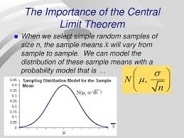

### **Example:**

If we have a non-normally distributed population, such as income data (which is often skewed), and we draw many samples of size 50, the distribution of the sample means will tend to be normal according to the CLT. This allows us to apply techniques that assume normality, like calculating confidence intervals for the mean income.

In summary, the Central Limit Theorem is crucial because it enables the use of normal distribution-based methods in statistical inference, making it possible to draw conclusions about population parameters from sample data, even when the population distribution is not normal.

**36. What is the difference between parameter estimation and hypothesis testing?**

Parameter estimation involves using sample data to estimate population parameters (like mean, variance), while hypothesis testing is used to test assumptions or claims about a population parameter.

### **Parameter Estimation:**

* **Purpose:** The goal of parameter estimation is to estimate the value of a population parameter (e.g., mean, proportion, variance) based on sample data.
* **Example:** Estimating the average height of a population by calculating the mean height from a sample of individuals. A point estimate might be 170 cm, while a confidence interval might be 168 cm to 172 cm with a 95% confidence level.

### **Hypothesis Testing:**

* **Purpose:** The goal of hypothesis testing is to make a decision about a population parameter by testing a specific hypothesis, typically involving a comparison between a null hypothesis (H₀) and an alternative hypothesis (H₁ or Ha).
* **Example:** Testing whether a new drug has a different effect than a placebo. The null hypothesis might state that there is no difference in effects (mean difference = 0), while the alternative hypothesis states that there is a difference.

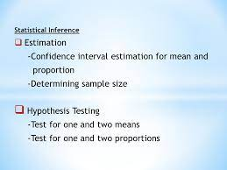

In summary, parameter estimation focuses on quantifying the value of a population parameter, while hypothesis testing focuses on making decisions about a population parameter based on sample data.

**37. What is the p-value in hypothesis testing?**

The p-value is the probability of obtaining a result at least as extreme as the observed data, assuming the null hypothesis is true. It helps determine the statistical significance of the observed effect.

**p-value < α: Reject H0**

### **How the p-value Works:**

* **Low p-value (< α):** A small p-value indicates that the observed data is unlikely under the null hypothesis, providing strong evidence against H₀. If the p-value is less than or equal to the chosen significance level (α, often set at 0.05), you reject the null hypothesis.
* **High p-value (> α):** A large p-value suggests that the observed data is consistent with the null hypothesis, and there isn't strong enough evidence to reject H₀. If the p-value is greater than α, you fail to reject the null hypothesis.

In summary, the p-value helps you decide whether to reject the null hypothesis by quantifying how unusual the observed data would be if the null hypothesis were true.

**38. What is confidence interval estimation?**

**Confidence interval estimation** is a statistical technique used to estimate a range within which a population parameter (such as a mean or proportion) is likely to fall, with a specified level of confidence. It provides an interval estimate rather than a single-point estimate, reflecting the uncertainty associated with sampling.A confidence interval is a range of values, derived from the sample data, that is likely to contain the population parameter with a specified probability (e.g., 95%).

**CI = (x̄ ± Z*σ/√n)**

Where:

* **Sample Mean** is the average of the sample data.
* **Critical Value** is a factor based on the desired confidence level (found from statistical tables).
* **Standard Deviation** is the standard deviation of the sample data.
* **Sample Size** is the number of observations in the sample.

**Confidence Interval (CI):** A confidence interval is a range of values, derived from sample data, that is likely to contain the true value of the population parameter. For example, a 95% confidence interval for a mean might be from 10 to 15.

**39. What are Type I and Type II errors in hypothesis testing?**

In hypothesis testing, **Type I** and **Type II errors** refer to the potential errors that can occur when making decisions about the null hypothesis. Here's a breakdown of each type:

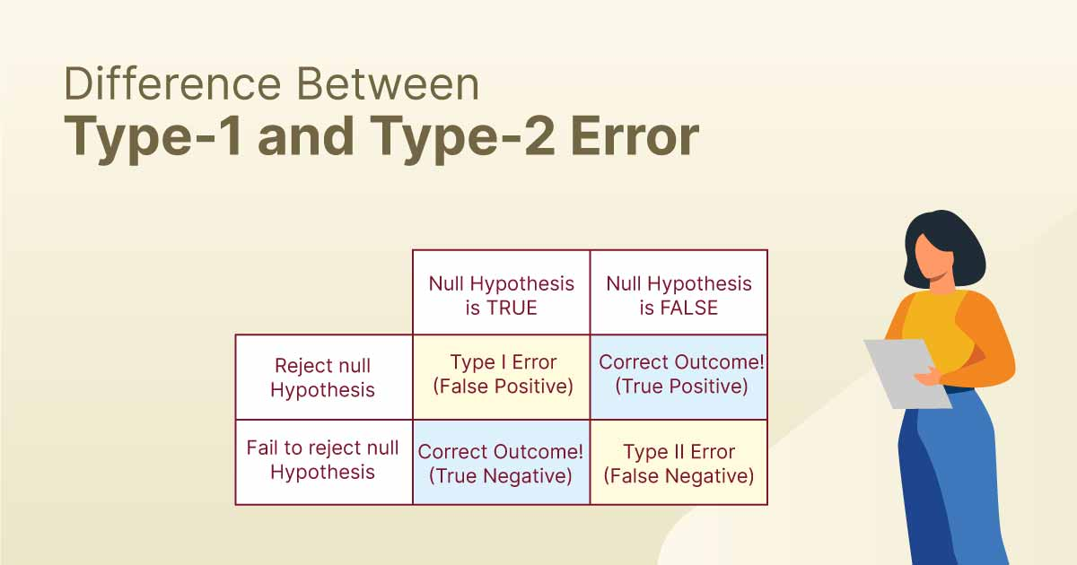

### **Type I Error (False Positive):**

* **Definition**: A Type I error occurs when the null hypothesis ( H 0​ ) is rejected when it is actually true. In other words, it's the mistake of concluding that there is an effect or difference when there is none.
* **Probability**: The probability of making a Type I error is denoted by α (alpha), which is also known as the significance level of the test. Common significance levels are 0.05, 0.01, or 0.10. For example, if α=0.05, there is a 5% chance of making a Type I error.
* **Example**: If a medical test incorrectly indicates that a patient has a disease when they do not, this is a Type I error.

**Type I: Reject H0 (H0 true)**

**Type II Error (False Negative):**

* **Definition**: A Type II error occurs when the null hypothesis ( H 0 ​ ) is not rejected when it is actually false. This means failing to detect an effect or difference when one actually exists.
* **Probability**: The probability of making a Type II error is denoted by β (beta). The power of the test, which is 1−β, represents the probability of correctly rejecting the null hypothesis when it is false.
* **Example**: If a medical test fails to detect a disease when the patient actually has it, this is a Type II error.

**Type II: Fail to Reject H0 (H1 true)**

### **Example:**

Suppose a new drug is being tested for effectiveness:

* Null Hypothesis (H0​): The drug has no effect.
* Alternative Hypothesis (H1​): The drug has an effect.
* Type I Error: Concluding that the drug is effective (rejecting H0​) when it is actually not effective (i.e., the drug has no effect).
* Type II Error: Concluding that the drug is not effective (failing to reject H0​) when it is actually effective (i.e., the drug does have an effect).

**40. How is a confidence interval defined in statistics?**

In statistics, a **confidence interval** (CI) is a range of values that is used to estimate the true value of a population parameter. It provides a measure of the precision and uncertainty associated with a sample estimate. Here’s a detailed breakdown:

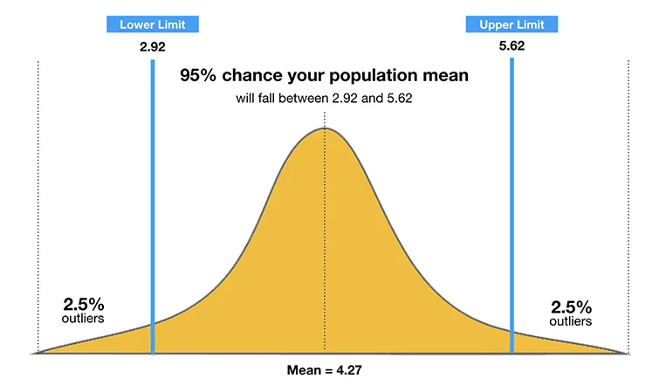

### **Definition:**

* **Confidence Interval:** A confidence interval is a range of values, derived from the sample data, that is likely to contain the true population parameter with a specified level of confidence.

**CI = (x̄ - ME, x̄ + ME)**

**Margin of Error:** This is the range around the point estimate that accounts for sampling variability. It is calculated using the standard error of the estimate and a critical value from the relevant probability distribution (e.g., Z-distribution for large samples, t-distribution for small samples).

**Confidence Level:** This represents the proportion of times that the confidence interval will contain the true parameter if the same sampling process is repeated many times. Common confidence levels are 90%, 95%, and 99%.

### **Summary:**

* **Purpose:** To estimate a range within which the true population parameter is likely to lie.
* **Confidence Level:** Reflects the reliability of the interval estimate.

**41. What does the confidence level represent in a confidence interval?**

The **confidence level** in a confidence interval represents the proportion of times that the confidence interval would contain the true population parameter if the same sampling process were repeated many times. It reflects the degree of certainty or reliability we have in the interval estimate.

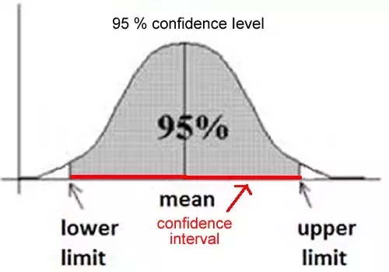

**Confidence Level (e.g., 95%):** If you have a 95% confidence level, it means that 95% of the confidence intervals constructed from repeated random samples of the same size would include the true population parameter.

**95% CI: true parameter within interval**

### **Example:**

If you calculate a 95% confidence interval for a population mean, you can say, "I am 95% confident that the true population mean lies within this interval." This means that if you were to draw many samples and calculate a confidence interval from each, 95% of those intervals would contain the true mean.

### **Summary:**

The confidence level indicates how confident you are that the interval estimation process will capture the true population parameter over many samples. It is a measure of the reliability of the interval, not of the probability that a particular interval contains the parameter.

**42. What is hypothesis testing in statistics?**

**Hypothesis testing** in statistics is a method used to make decisions or draw conclusions about a population parameter based on sample data. It involves formulating two competing hypotheses and using statistical tests to determine which hypothesis is supported by the data.

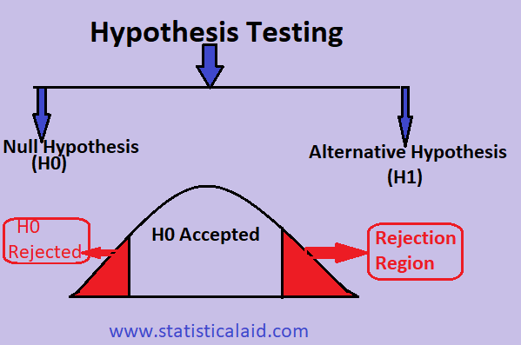

**Null Hypothesis (H₀):**

* The null hypothesis is a statement that there is no effect or no difference, and it serves as the default or baseline assumption.

**Alternative Hypothesis (H₁ or Ha):**

* The alternative hypothesis is a statement that contradicts the null hypothesis. It represents the outcome that the test is designed to detect.

**Test Statistic:**

* A test statistic is a standardized value calculated from the sample data that is used to decide whether to reject the null hypothesis.

**P-Value:**

* The p-value is the probability of observing the test statistic or something more extreme, assuming that the null hypothesis is true.

**Decision:**

* Based on the p-value and the significance level, a decision is made to either reject or fail to reject the null hypothesis.

### **Example:**

Suppose a researcher wants to test whether a new drug has a different effect than the current standard. The null hypothesis (H₀) might state that there is no difference in effects (i.e., the mean difference is zero), while the alternative hypothesis (Ha) states that there is a difference.

After conducting the study and calculating the test statistic, the researcher finds a p-value of 0.03. If the significance level was set at 0.05, the researcher would reject the null hypothesis, concluding that there is evidence to suggest the new drug has a different effect.

### **Summary:**

Hypothesis testing is a formal process for evaluating whether sample data provides enough evidence to support or refute a specific hypothesis about a population parameter. It's a fundamental tool in statistical inference, used in a wide range of scientific and research contexts.

**43. What is the purpose of a null hypothesis in hypothesis testing?**

The null hypothesis provides a default position that there is no effect or no difference. It serves as a statement to be tested and possibly rejected based on sample data.

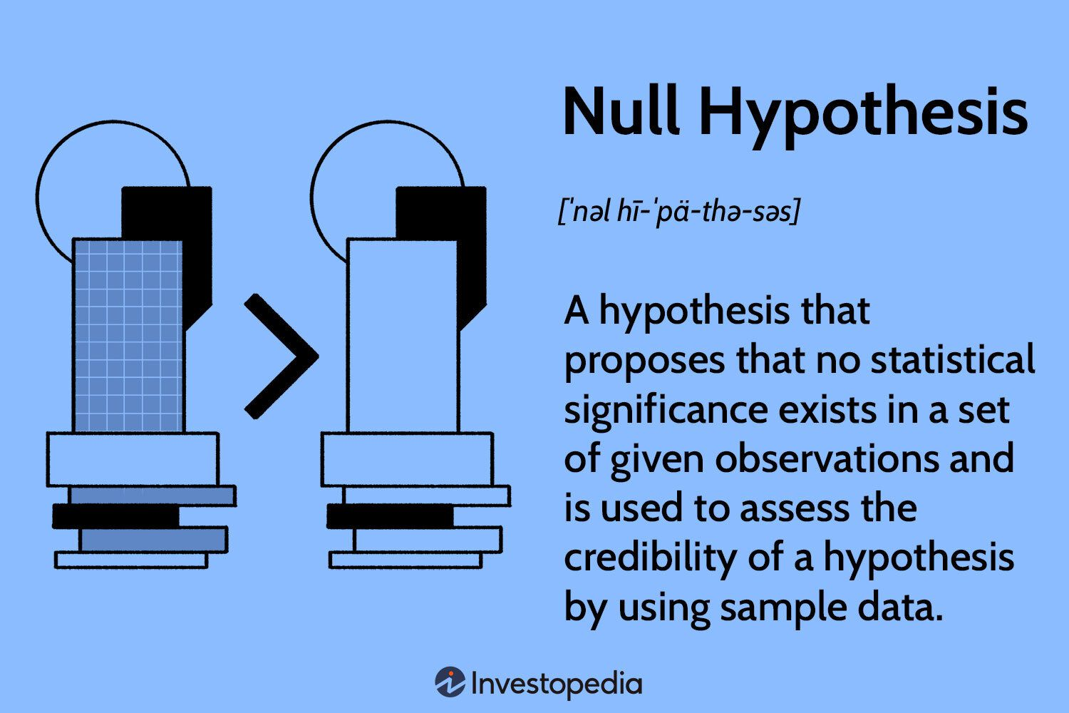

The purpose of this null hypothesis is to set a standard of no effect that can be tested against the observed data. If the data show a statistically significant difference in blood pressure between the drug and placebo groups, the null hypothesis may be rejected, supporting the claim that the drug has an effect.

**44. What is the difference between a one-tailed and a two-tailed test?**

A one-tailed test tests for an effect in one direction, while a two-tailed test tests for an effect in either direction.

**One-tailed: H0: μ ≤ μ0 Two-tailed: H0: μ = μ0**

### **Visual Representation:**

* **One-Tailed Test:** The critical region for rejecting the null hypothesis is on one side of the distribution (either the left tail or the right tail).
* **Two-Tailed Test:** The critical region is split between both tails of the distribution, covering both the possibility of the parameter being greater or less than the hypothesized value.

### **Choosing Between the Two:**

* A **one-tailed test** is appropriate when the hypothesis is directional and you are only interested in deviations in a specific direction.
* A **two-tailed test** is appropriate when the hypothesis is non-directional, and you want to test for any possible deviation, regardless of the direction.

**45. What is experiment design, and why is it important?**

**Experimental design** refers to the process of planning, structuring, and conducting an experiment to ensure that valid, reliable, and interpretable results are obtained. It involves selecting the appropriate variables, determining how they will be measured, and deciding how data will be collected and analyzed.

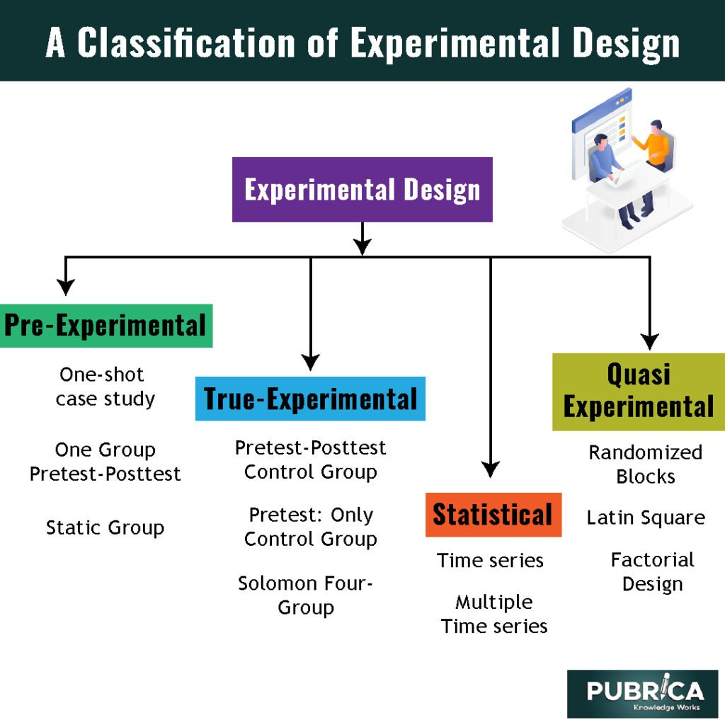

### **Conclusion:**

Experimental design is crucial in research because it provides a framework that guides the conduct of experiments, ensuring that the results are valid, reliable, and meaningful. Without proper design, experiments may produce misleading or inconclusive results, limiting their contribution to knowledge and decision-making.

**46. What are the key elements to consider when designing an experiment?**

Key elements include defining the hypothesis, selecting the sample, choosing the variables (independent and dependent), controlling confounding variables, and ensuring randomization.

**Hypothesis -> Variables -> Sample -> Control -> Randomize**

When designing an experiment, several key elements need to be considered to ensure that the study is methodologically sound, produces valid results, and addresses the research question effectively. These elements include:

* Research Question and Hypothesis
* Variables
* Sample Size and Selection
* Data Collection Methods
* Statistical Analysis
* Analysis
* Reporting and Documentation

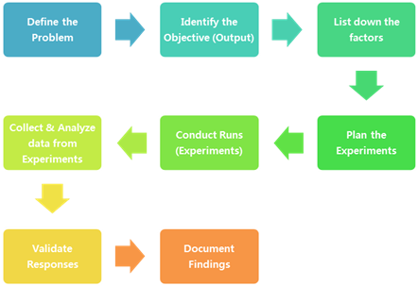

By carefully considering these elements, researchers can design experiments that are rigorous, ethical, and capable of producing meaningful and reliable results.

**47. How can sample size determination affect experiment design?**

Sample size determination is a critical aspect of experiment design, as it directly affects the validity, reliability, and generalizability of the study's findings. Here's how sample size determination influences experiment design:

* Statistical Power
* Effect Size Detection
* Confidence Intervals
* Cost and Resource Allocation
* Type I and Type II Errors
* Design Complexity

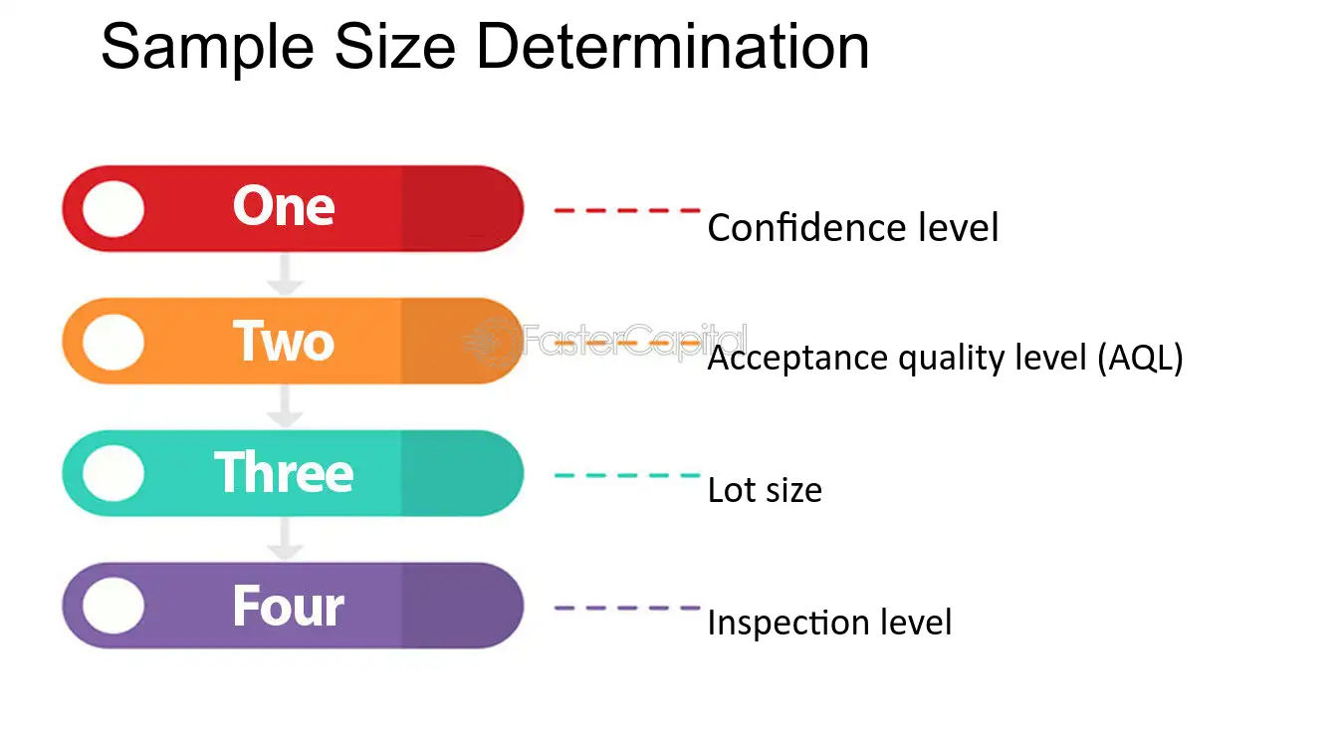

In summary, sample size determination is vital for designing an experiment that yields valid, reliable, and generalizable results. It ensures that the study is adequately powered to detect the effects of interest, provides precise estimates, and balances ethical and resource considerations.

**48. How are confidence tests and hypothesis tests similar? How are they different?**

**Similarities between Confidence Tests and Hypothesis Tests:**

1. **Both Involve Sampling**: Both confidence tests (confidence intervals) and hypothesis tests involve drawing samples from a population to make inferences about population parameters.
2. **Statistical Inference**: Both are used in statistical inference to draw conclusions about a population based on sample data.
3. **Depend on Probability Distributions**: Both rely on the properties of probability distributions, particularly the normal distribution (or t-distribution, depending on sample size and variance knowledge).
4. **Account for Variability**: Both methods account for sampling variability and the uncertainty that comes with using sample data to make population inferences.
5. **Used to Assess Population Parameters**: Both methods are used to assess population parameters, such as means, proportions, and variances.

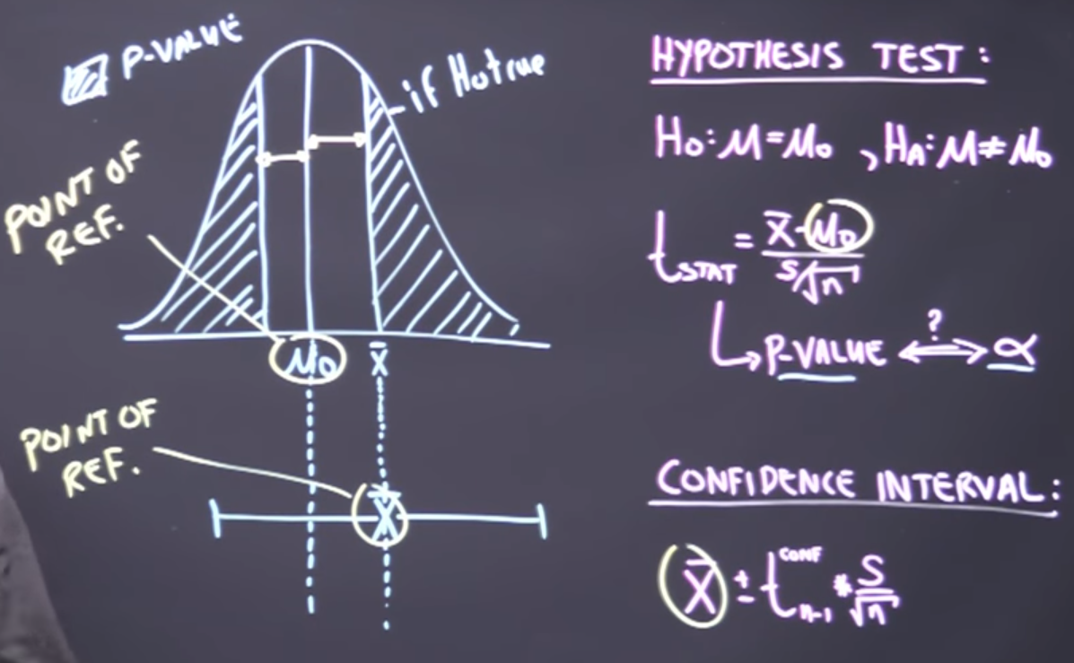

In summary, confidence intervals and hypothesis tests are both fundamental tools in inferential statistics, often used together or in complementary ways. Confidence intervals are focused on estimation, providing a range of plausible values for a parameter, while hypothesis tests are focused on decision-making, determining whether the sample data provides sufficient evidence to reject a null hypothesis.

**49. What is the left-skewed distribution and the right-skewed distribution?**

### **Left-Skewed Distribution (Negatively Skewed)**

* **Definition:** In a left-skewed distribution, also known as a negatively skewed distribution, the tail on the left side of the distribution is longer or fatter than the right side. The majority of the data values are concentrated on the higher end (right side) of the distribution, with a few lower values pulling the mean to the left.
* **Characteristics:**
  + **Mean < Median < Mode:** The mean is less than the median, which is less than the mode.
  + **Tail:** The long tail is on the left side of the distribution.
  + **Example:** Income distributions in certain low-income communities, where most people earn above a certain amount, but there are a few outliers with very low income.

### **Right-Skewed Distribution (Positively Skewed)**

* **Definition:** In a right-skewed distribution, also known as a positively skewed distribution, the tail on the right side of the distribution is longer or fatter than the left side. The majority of the data values are concentrated on the lower end (left side) of the distribution, with a few higher values pulling the mean to the right.
* **Characteristics:**
  + **Mode < Median < Mean:** The mode is less than the median, which is less than the mean.
  + **Tail:** The long tail is on the right side of the distribution.
  + **Example:** Income distributions in wealthy communities, where most people earn below a certain high amount, but there are a few outliers with extremely high incomes.

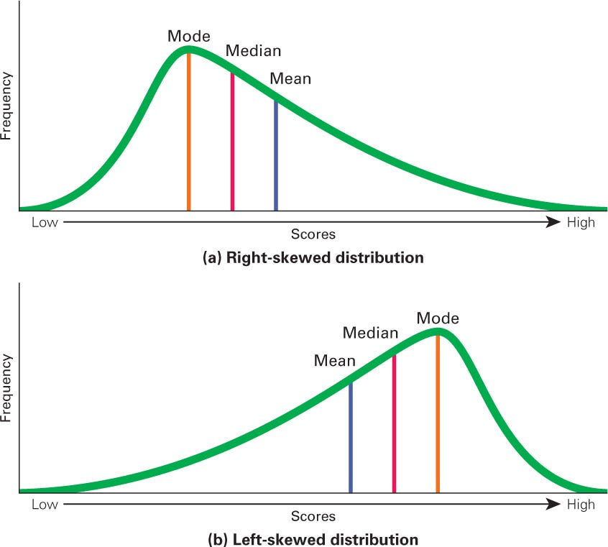

For example, in a right-skewed distribution, using the mean as a measure of central tendency could be misleading due to the influence of outliers.

**50. What is kurtosis?**

Kurtosis is a statistical measure that describes the shape of the distribution of data, specifically focusing on the tails and the peak of the distribution. It provides insight into the "tailedness" or outliers in the data compared to a normal distribution.

**Types of Kurtosis**

* Mesokurtic
* Leptokurtic
* Platykurtic

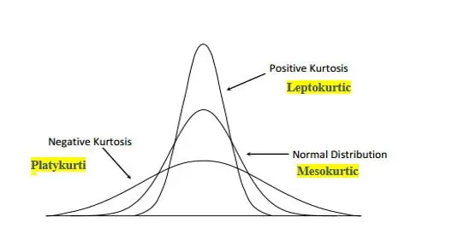

Understanding kurtosis helps in analyzing the propensity of a dataset to produce outliers and assists in selecting appropriate statistical methods and models.

**Video Link -**

**GitHub Link -**

**—---------------------Thank You—-----------------------**